Psinergy Empathy Workbook
Empathy is not located in a single spot, but rather involves a network of brain regions that work together. Key areas include the anterior insula, anterior cingulate cortex, medial prefrontal cortex, temporoparietal junction, and amygdala. These areas are involved in different aspects of empathy, such as understanding others' emotions, experiencing emotional responses, and regulating those responses.
Anterior Insula:
This region is crucial for representing internal bodily states and emotional responses, allowing us to feel what others might be feeling.
Anterior Cingulate Cortex (ACC):
The ACC is involved in processing emotional and cognitive information related to empathy, including experiencing emotional responses and understanding another person's perspective.
Medial Prefrontal Cortex:
This area is important for understanding others' mental states and intentions, as well as self-regulation of emotions.
Temporoparietal Junction (TPJ):
The TPJ is involved in shifting attention and perspective-taking, allowing us to consider things from another person's point of view.
Amygdala:
This region plays a role in processing emotional information, particularly fear and threat-related emotions, which can be involved in empathetic responses.

New York, NY
(September 01, 2012)
An international team led by researchers at Mount Sinai School of Medicine in New York has for the first time shown that one area of the brain, called the anterior insular cortex, is the activity center of human empathy, whereas other areas of the brain are not. The study is published in the September 2012 issue of the journal Brain.
https://www.mountsinai.org/about/newsroom/2012/researchers-identify-area-of-the-brain-that-processes-empathy

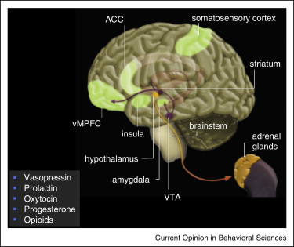
https://www.sciencedirect.com/science/article/abs/pii/S2352154614000321
Current Opinion in Behavioral Sciences
Volume 3, June 2015, Pages 1-6

The neural pathways, development and functions of empathy
Empathy has evolved in the context of parental care and kinship relationships.
Conserved neural circuits connecting brainstem, basal ganglia, insula and orbitofrontal cortex.
It emerges early in life.
Empathy is modulated by interpersonal and contextual factors.
Empathy is flexible and can be promoted.
Empathy reflects an innate ability to perceive and be sensitive to the emotional states of others coupled with a motivation to care for their wellbeing. It has evolved in the context of parental care for offspring as well as within kinship. Current work demonstrates that empathy is underpinned by circuits connecting the brainstem, amygdala, basal ganglia, anterior cingulate cortex, insula and orbitofrontal cortex, which are conserved across many species. Empirical studies document that empathetic reactions emerge early in life, and that they are not automatic. Rather they are heavily influenced and modulated by interpersonal and contextual factors, which impact behavior and cognitions. However, the mechanisms supporting empathy are also flexible and amenable to behavioral interventions that can promote caring beyond kin and kith.
https://pmc.ncbi.nlm.nih.gov/articles/PMC3427869/
Soc Cogn Affect Neurosci
. 2011 Sep 5;7(6):727–737. doi: 10.1093/scan/nsr051
The balance between feeling and knowing: affective and cognitive empathy are reflected in the brain's intrinsic functional dynamics
Affective empathy (AE) is distinguished clinically and neurally from cognitive empathy (CE). While AE is selectively disrupted in psychopathy, autism is associated with deficits in CE. Despite such dissociations, AE and CE together contribute to normal human empathic experience. A dimensional measure of individual differences in AE ‘relative to’ CE captures this interaction and may reveal brain–behavior relationships beyond those detectable with AE and CE separately. Using resting-state fMRI and measures of empathy in healthy adults, we show that relative empathic ability (REA) is reflected in the brain's intrinsic functional dynamics. Dominance of AE was associated with stronger functional connectivity among social–emotional regions (ventral anterior insula, orbitofrontal cortex, amygdala, perigenual anterior cingulate). Dominance of CE was related to stronger connectivity among areas implicated in interoception, autonomic monitoring and social–cognitive processing (brainstem, superior temporal sulcus, ventral anterior insula). These patterns were distinct from those observed with AE and CE separately. Finally, REA and the strength of several functional connections were associated with symptoms of psychopathology. These findings suggest that REA provides a dimensional index of empathic function and pathological tendencies in healthy adults, which are reflected in the intrinsic functional dynamics of neural systems associated with social and emotional cognition.
Keywords: affective empathy, cognitive empathy, fMRI, resting-state functional connectivity, social cognition
Neuroimaging studies typically highlight brain regions implicated in empathy more generally (Carr et al., 2003; Zaki et al., 2009; Decety, 2010; Fan et al., 2011) often due to a lack of agreement regarding the terminology and cognitive constructs employed [e.g. empathy for pain (Decety, 2010), Theory of Mind (ToM) (Saxe, 2006), automatic vs controlled empathy (Fan et al., 2011)]. Nonetheless, several studies point to distinctions in the neural correlates of AE and CE. During a social–emotional task, activation in inferior frontal gyrus, supramarginal gyrus and superior temporal sulcus was related to CE, while activation in precentral gyrus was associated with AE (Hooker et al., 2010). In addition, AE as opposed to CE tasks preferentially recruit the insula, brainstem, inferior parietal lobule, thalamus (Nummenmaa et al., 2008) and medial orbitofrontal cortex (OFC) (Hynes et al., 2006).
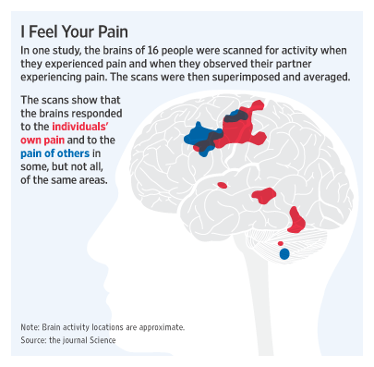
https://www.emory.edu/LIVING_LINKS/empathy/Reviewfiles/WSJ.html
Emory University
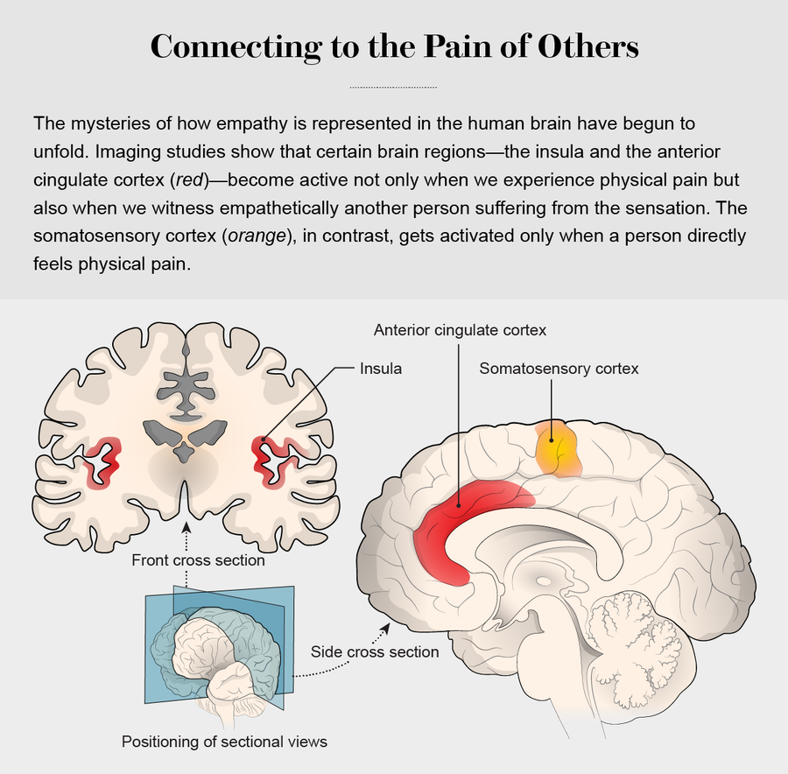
https://www.scientificamerican.com/article/the-good-and-bad-of-empathy/
DECEMBER 1, 2017
The Good and Bad of Empathy
New insights into the underpinnings of empathy might help us harness the emotion—just when we need it the most
Fifteen years of neuroscientific investigation has led most scientists to see empathy as an umbrella term covering three main components. Emotional empathy—sharing another's feelings and matching that person's behavioral states (feeling afraid, for instance, when someone else is on a tightrope)—is a biological response found in many different species that evolved in the context of parental care and group living. Cognitive empathy, also called perspective taking or theory of mind, is the capacity to think about and understand another's feelings. And empathetic concern, or compassion, adds the motivation to do something about another's suffering. Taken together, these components are fundamental elements of our social lives.

Neuroscience & Biobehavioral Reviews
Volume 37, Issue 8, September 2013, Pages 1537-1548

Review
Towards a neuroscience of empathy: Ontogeny, phylogeny, brain mechanisms, context and psychopathology
Empathy has evolved along with mammalian parental care.
Mimicry, emotional contagion, sympathy, and compassion are related but not identical to empathy.
Empathy is processed by a distinct neural network comprising limbic and neocortical areas.
Empathy, as well as its “adversaries” envy and schadenfreude, is modulated by context.
Several psychopathological disorders exhibit profound empathy deficits.
https://www.sciencedirect.com/science/article/abs/pii/S0149763413001152

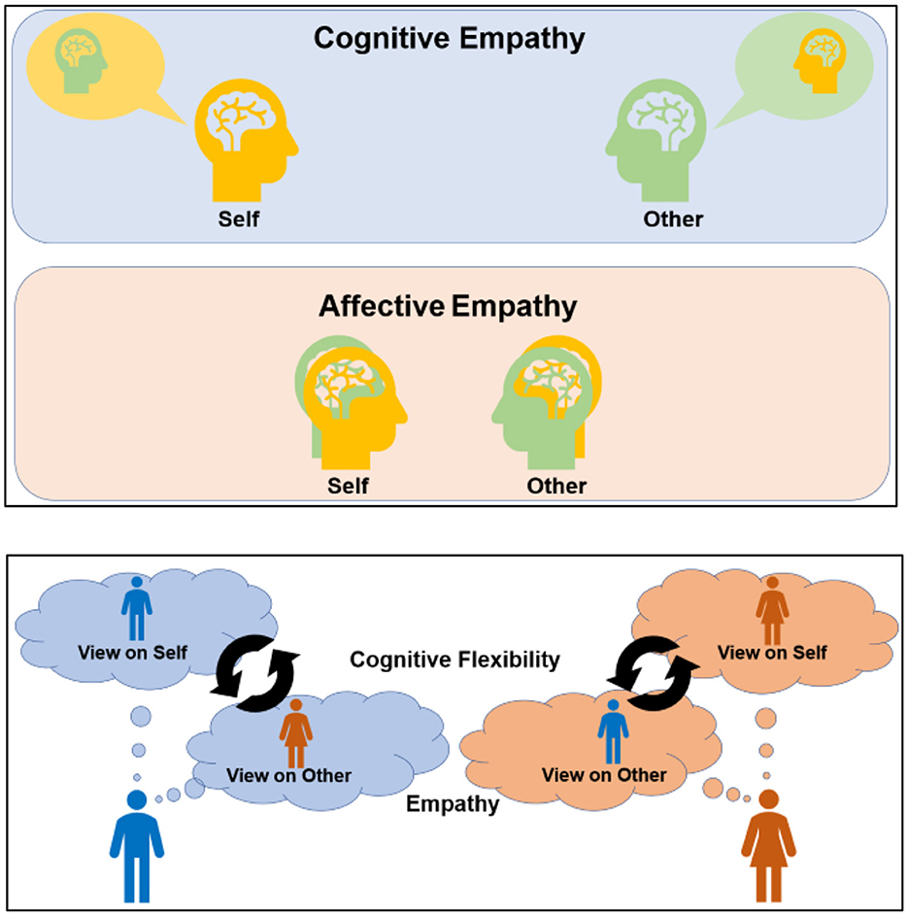
https://www.frontiersin.org/journals/psychology/articles/10.3389/fpsyg.2023.1090297/full
Figure 1. Illustration of empathy and cognitive flexibility. CogEMP allows individuals to obtain accurate knowledge regarding the content of another person's mind and often requires a self–other distinction to identify others' minds more clearly. Meanwhile, AffEMP promotes the sharing of others' feelings, such as joy and distress and involves the self–other overlap of emotional experiences (upper panels). Cognitive flexibility requires self-control to adapt to changing environments via shifts in decision rules and perspectives. It also supports the switching and maintenance of perspectives between the self and others to facilitate empathy, which prompts social communication that is adaptable and context-adjusted (lower panel). Meanwhile, altered cognitive flexibility and empathy may hinder flexible emotion regulation and shifting attention and perspectives. They can maladaptively amplify shared distress and perspective bias (empathic inaccuracy), which can prompt people to acknowledge interpersonal communication or experiences as socially traumatic.
Front. Psychol., 25 May 2023
Sec. Personality and Social Psychology
Volume 14 - 2023 | https://doi.org/10.3389/fpsyg.2023.1090297
Adverse effects of empathy and cognitive inflexibility on social trauma
The key feature of traumatic events defined in the Diagnostic and Mental Manual of Mental Disorders (DSM) can be threats to life (e.g., exposure to death, serious injury, or violence; American Psychiatric Association, 2013). Researchers argue that additional approaches should be utilized to further evaluate what makes an experience traumatic (Bjornsson et al., 2020; Neuner, 2022). In the case of post-traumatic stress disorder (PTSD) and other disorders such as social anxiety disorder (SAD), different types of threats can play crucial roles in their development (Erwin et al., 2006; Carleton et al., 2011). One such threat is social trauma (Hamburger, 2021).
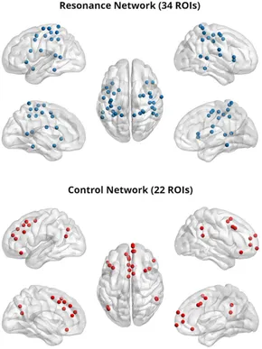
Figure 1. Resonance (top) and control (bottom) networks; 5 mm regions of interest were visualized with the BrainNet Viewer (http://www.nitrc.org/projects/bnv/) (Xia et al., 2013).
https://www.frontiersin.org/journals/integrative-neuroscience/articles/10.3389/fnint.2020.00003/full
Front. Integr. Neurosci., 13 February 2020
Volume 14 - 2020 | https://doi.org/10.3389/fnint.2020.00003
Predicting Empathy From Resting State Brain Connectivity: A Multivariate Approach
Is this to be an empathy test? ~ bladerunner
Recent task fMRI studies suggest that individual differences in trait empathy and empathic concern are mediated by patterns of connectivity between self-other resonance and top-down control networks that are stable across task demands. An untested implication of this hypothesis is that these stable patterns of connectivity should be visible even in the absence of empathy tasks. Using machine learning, we demonstrate that patterns of resting state fMRI connectivity (i.e. the degree of synchronous BOLD activity across multiple cortical areas in the absence of explicit task demands) of resonance and control networks predict trait empathic concern (n = 58). Empathic concern was also predicted by connectivity patterns within the somatomotor network. These findings further support the role of resonance-control network interactions and of somatomotor function in our vicariously driven concern for others. Furthermore, a practical implication of these results is that it is possible to assess empathic predispositions in individuals without needing to perform conventional empathy assessments.
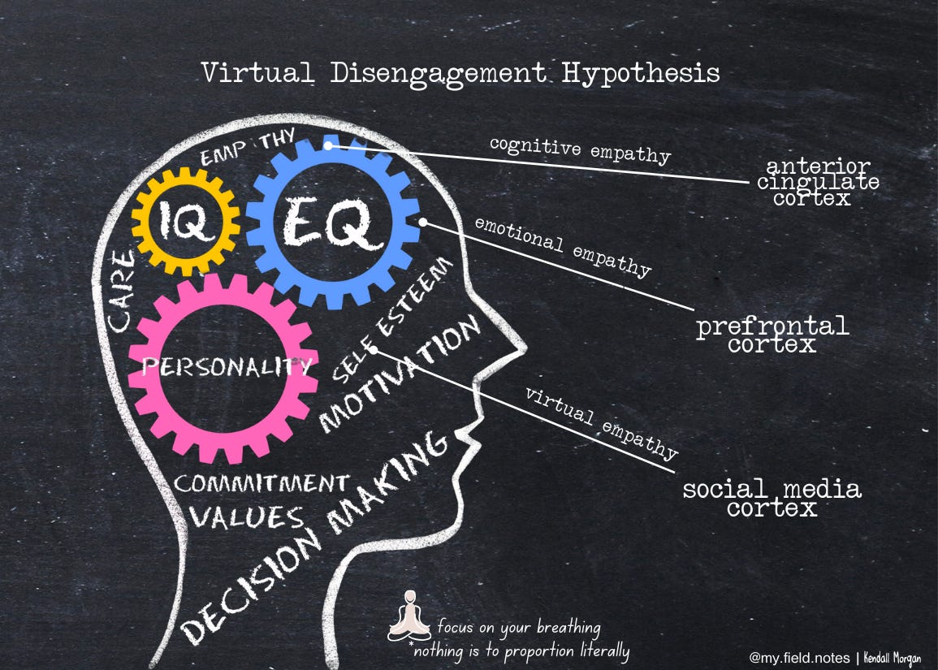
Front. Hum. Neurosci., 07 May 2013
Sec. Cognitive Neuroscience
Volume 7 - 2013 | https://doi.org/10.3389/fnhum.2013.00160
The role of automaticity and attention in neural processes underlying empathy for happiness, sadness, and anxiety
Although many studies have examined the neural basis of empathy, relatively little is known about how empathic processes are affected by different attentional conditions. Thus, we examined whether instructions to empathize might amplify responses in empathy-related regions and whether cognitive load would diminish the involvement of these regions.
https://www.frontiersin.org/journals/human-neuroscience/articles/10.3389/fnhum.2013.00160/full
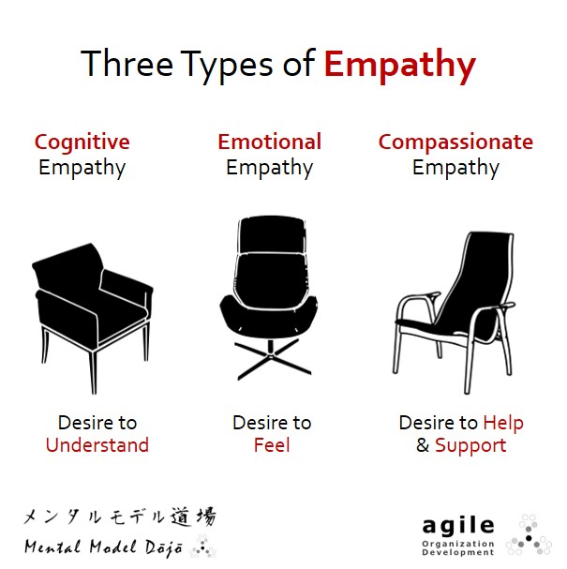
Neuroscience & Biobehavioral Reviews
Volume 35, Issue 3, January 2011, Pages 903-911
https://www.sciencedirect.com/science/article/abs/pii/S0149763410001739


Review
Is there a core neural network in empathy? An fMRI based quantitative meta-analysis
Whilst recent neuroimaging studies have identified a series of different brain regions as being involved in empathy, it remains unclear concerning the activation consistence of these brain regions and their specific functional roles. Using MKDA, a whole-brain based quantitative meta-analysis of recent fMRI studies of empathy was performed. This analysis identified the dACC-aMCC-SMA and bilateral anterior insula as being consistently activated in empathy. Hypothesizing that what are here termed affective–perceptual and cognitive–evaluative forms of empathy might be characterized by different activity patterns, the neural activations in these forms of empathy were compared. The dorsal aMCC was demonstrated to be recruited more frequently in the cognitive–evaluative form of empathy, whilst the right anterior insula was found to be involved in the affective–perceptual form of empathy only. The left anterior insula was active in both forms of empathy. It was concluded that the dACC-aMCC-SMA and bilateral insula can be considered as forming a core network in empathy, and that cognitive–evaluative and affective–perceptual empathy can be distinguished at the level of regional activation.

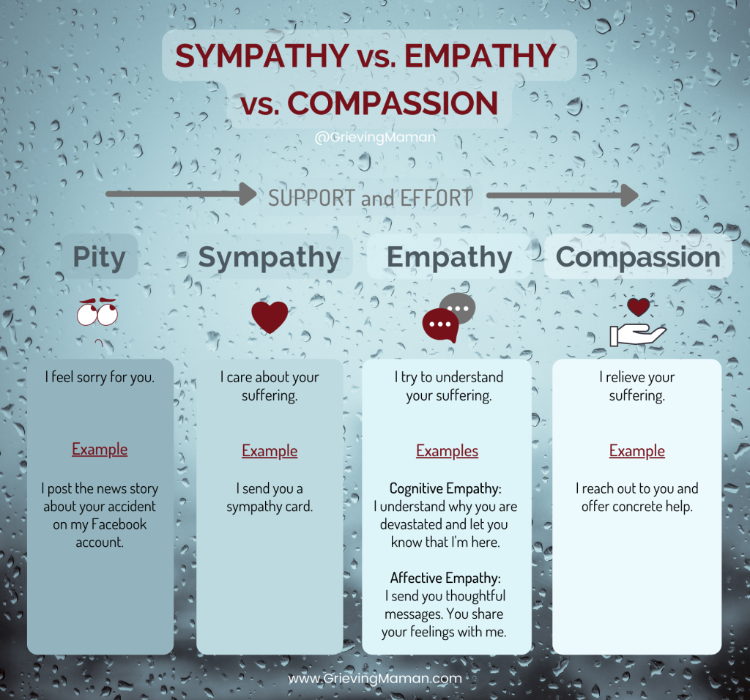
https://www.frontiersin.org/journals/behavioral-neuroscience/articles/10.3389/fnbeh.2018.00289/full
Front. Behav. Neurosci., 26 November 2018
Sec. Pathological Conditions
Volume 12 - 2018 | https://doi.org/10.3389/fnbeh.2018.00289
Is Empathy for Pain Unique in Its Neural Correlates? A Meta-Analysis of Neuroimaging Studies of Empathy
Empathy is an essential component of our social lives, allowing us to understand and share other people's affective and sensory states, including pain. Evidence suggests a core neural network—including anterior insula (AI) and mid-cingulate cortex (MCC)—is involved in empathy for pain. However, a similar network is associated to empathy for non-pain affective states, raising the question whether empathy for pain is unique in its neural correlates. Furthermore, it is yet unclear whether neural correlates converge across different stimuli and paradigms that evoke pain-empathy. We performed a coordinate-based activation likelihood estimation (ALE) meta-analysis to identify neural correlates of empathy, assess commonalities and differences between empathy for pain and for non-pain negative affective states, and differences between pain-empathy evoking stimuli (i.e., facial pain expressions vs. acute pain inflictions) and paradigms (i.e., perceptual/affective vs. cognitive/evaluative paradigms). Following a systematic search, data from 128 functional brain imaging studies presenting whole-brain results of an empathy condition vs. baseline/neutral condition were extracted. Synthesizing neural correlates of empathy confirmed a core network comprising AI, MCC, postcentral gyrus, inferior parietal lobe, thalamus, amygdala, and brainstem. There was considerable overlap in networks for empathy for pain and empathy for non-pain negative affective states. Important differences also arose: empathy for pain uniquely activated bilateral mid-insula and more extensive MCC. Regarding stimuli, painful faces and acute pain inflictions both evoked the core empathy regions, although acute pain inflictions activated additional regions including medial frontal and parietal cortex.

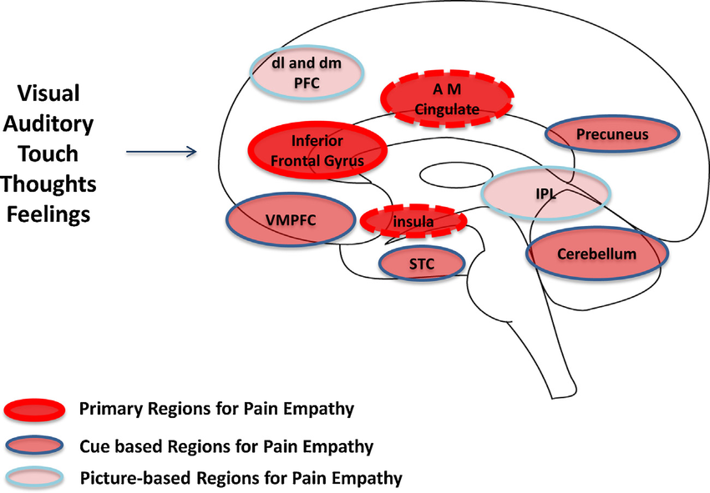
https://www.researchgate.net/figure/Key-brain-regions-for-empathy-The-figure-adapted-from-Lamm-et-al-2011-summarizes_fig1_304196065
Key brain regions for empathy. The figure (adapted from (Lamm et al., 2011) summarizes data implicating complex neural networks that overlap for empathy: These include (1) primary regions for pain empathy which themselves have a large overlap with pain activations in experimental pain; (2) cue based regions for pain empathy that encompass complex visual, social and other signals; and (3) picture-based regions for pain empathy that aside from the specific salience of pictures used in the experimental setting, clearly visual inputs related to pictures may contribute to an aversive process. Although only one side of the brain is depicted in the figure, these results are not lateralized.
Circles of Engagement: Childhood Pain and Parent Brain
- Jun 2016
https://blog.mindvalley.com/cognitive-empathy/
Mind
- Published on July 2, 2025
What cognitive empathy is—and why it matters more than you think
The “cognitive empathy” definition is simply this: the ability to understand someone’s mental state without being swept up in their emotional experience. It allows you to read between the lines, decode tone, anticipate reactions, and recognize unspoken needs.
It’s part of the trio of empathies:
- Affective empathy (you feel what they feel),
- Compassionate empathy (you want to help), and
- Cognitive empathy (you get where they’re coming from).
Empathy in itself is a super skill, according to Vanessa. In a video on her YouTube channel, she explains, “People with high empathy are able to 1) relate to others’ experiences, 2) mirror another person’s emotions, and 3) sense what others around them are feeling.”
And while all three matter, cognitive empathy is the foundation of effective communication. It lights up the prefrontal cortex (not the emotional limbic system), so you don’t have to feel what they feel but still step into another person’s internal world and see things from their point of view.
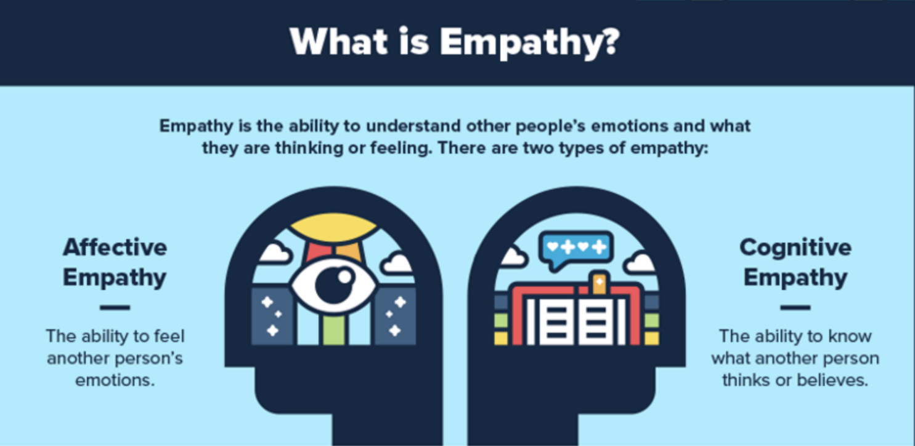
https://pmc.ncbi.nlm.nih.gov/articles/PMC3524680/
Med Sci Monit
. 2011 Jan 1;17(1):RA18–RA24. doi: 10.12659/MSM.881324
How we empathize with others: A neurobiological perspective
Empathy allows us to internally simulate the affective and cognitive mental states of others. Neurobiological studies suggest that empathy is a complex phenomenon, which can be described using a model that includes 2 modes of processing: bottom-up and top-down. Bottom-up neural processing is achieved via the mirroring representation systems that play a key role in the direct sharing of the emotional states of others. Top-down processing, known as cognitive perspective-taking or theory of mind, where the feelings of others are fully imagined and understood, is based on control and inhibition mechanisms. Available evidence indicates that empathic brain responses are likely to be influenced by several different modulating factors.
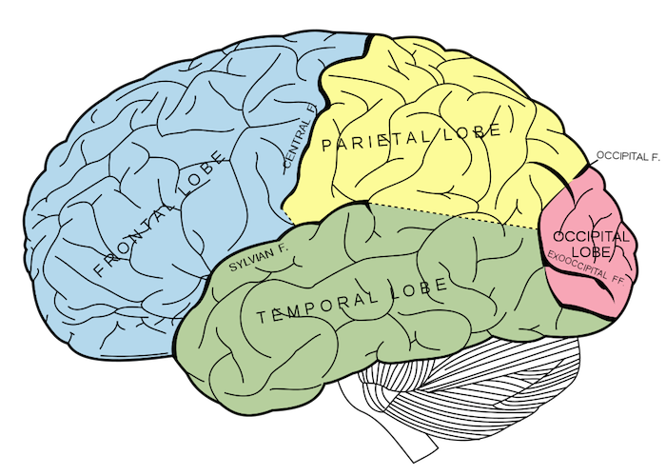
Mirror neurons represent a distinctive class of neurons that discharge both when an individual executes a motor act and when he observes another individual performing the same or a similar motor act. These neurons were first discovered in monkey's brain.
Mirror Neurons & Empathy: Experiencing Another’s Inner World with Clarity instead of Fear.
https://www.elephantjournal.com/2014/12/mirror-neurons-empathy-experiencing-anothers-inner-world-with-clarity-instead-of-fear/
“Mirror neurons” are a neuron population that exists in our brain and displays an extraordinary property.
They are triggered both when performing an action and when observing another individual performing the same action.
Mirror neurons therefore allow us to realize what others are doing and understand their intentions, for the very reason that they allow us to experience what we are observing firsthand, as if we were performing that action ourselves.
This means that they enable us to recognize other people’s emotions simply by observing them. When we observe somebody else, these mirror neurons are activated and allow us to at least partly feel the emotions that the person we are observing is feeling.
As with the “motor” mirrors, the “empathic” mirrors are triggered both when we experience an emotion and when we observe somebody who is experiencing the same emotion. This extraordinary finding therefore provides the neurophysiological grounds for empathy, which is both understandable and researchable.
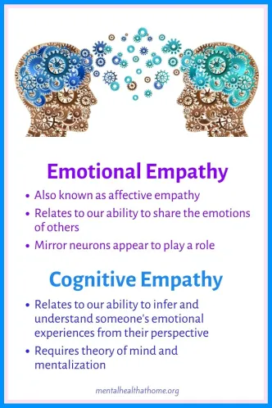
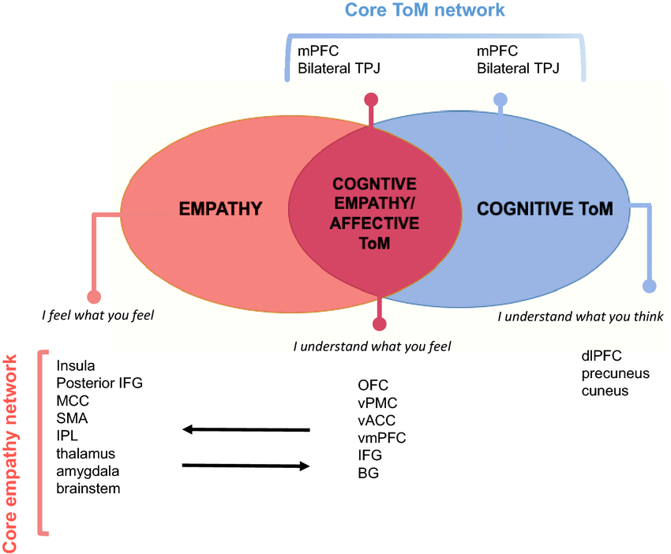

https://www.researchgate.net/figure/Model-of-the-relationship-between-empathy-affective-Theory-of-Mind-ToM-or-cognitive_fig2_356390737
Model of the relationship between empathy, affective Theory of Mind (ToM or cognitive empathy), and cognitive ToM. Cognitive ToM is required for a successful affective ToM, which also interacts with emotional empathy. Brain areas mostly engaged in each process are reported. BG basal ganglia, dlPFC dorsolateral prefrontal cortex, IFG inferior frontal gyrus, IPL inferior parietal lobule, MCC mid-cingulate cortex, mPFC medial prefrontal cortex, OFC orbitofrontal cortex, SMA supplementary motor area, TPJ temporoparietal junction, vACC ventral anterior cingulate cortex, vmPFC ventromedial prefrontal cortex, vPMC ventral premotor cortex
Over the past few years, there has been great interest in social cognition, a wide term referring to the human ability of understanding others’ emotions, thoughts, and intentions, to empathize with them and to behave accordingly.
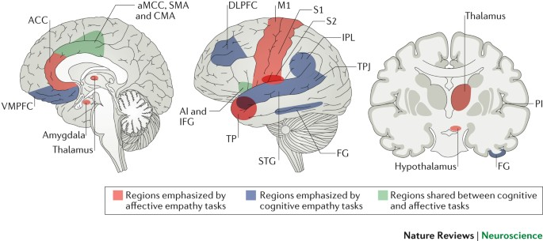
https://www.nature.com/articles/nrn.2017.72
- Review Article
- Published: 29 June 2017
Mammalian empathy: behavioural manifestations and neural basis
- Observational and experimental studies dating back to the 1950s demonstrate that mammals spontaneously help distressed conspecifics. Research emphasizes the untrained, unrewarded nature of this behaviour, which is also biased towards familiar individuals, thus arguing against explanations that are exclusively based on associative learning or conditioning.
https://www.cell.com/neuron/fulltext/S0896-6273%2817%2930415-4
ARTICLEVolume 94, Issue 6P1263-1273.E4June 21, 2017Open Archive
Download Full Issue
Empathic Care and Distress: Predictive Brain Markers and Dissociable Brain Systems
Distinctions among multiple systems are central to recent conceptualizations of empathy and compassion (Ashar et al., 2016a; de Waal, 2008; Kanske et al., 2016; Shamay-Tsoory et al., 2009; Singer and Klimecki, 2014; Zaki and Ochsner, 2012). An “affective empathy” system is believed to support the sharing or simulation of others’ affective experiences, often leading to personal distress for the empathizer. A “cognitive empathy” system, related to mentalizing and perspective-taking, supports the conceptual understanding of others’ internal states. And an “empathic care” system supports responding to others’ distress with warmth and care and is closely associated with sympathy and compassion. These distinctions—especially between empathic care and empathic distress—are at the heart of several recent debates. Scientists have argued that shared experiences of distress are a poor guide for moral behavior and public policy, which ought to instead rely on empathic care and perspective-taking (Bloom, 2016; Lamm and Majdandžić, 2015); that empathic distress causes burnout among professional caregivers, whereas empathic care leads to sustained functioning and fulfillment (Klimecki and Singer, 2011; Caroe, 2012); and that empathic distress leads to avoidance, whereas empathic care leads to helping behavior (Batson, 2011; Batson et al., 1987; Eisenberg et al., 1989).
https://greatergood.berkeley.edu/images/uploads/The_Neural_Basis_of_Empathy.pdf
Keywords social neuroscience, insula, cingulate cortex, fMRI, emotion Abstract Empathy—the ability to share the feelings of others—is fundamental to our emotional and social lives. Previous human imaging studies focusing on empathy for others’ pain have consistently shown activations in regions also involved in the direct pain experience, particularly anterior insula and anterior and midcingulate cortex. These findings suggest that empathy is, in part, based on shared representations for firsthand and vicarious experiences of affective states. Empathic responses are not static but can be modulated by person characteristics, such as degree of alexithymia. It has also been shown that contextual appraisal, including perceived fairness or group membership of others, may modulate empathic neuronal activations. Empathy often involves coactivations in further networks associated with social cognition, depending on the specific situation and information available in the environment. Empathyrelated insular and cingulate activity may reflect domain-general computations representing and predicting feeling states in self and others, likely guiding adaptive homeostatic responses and goal-directed behavior in dynamic social contexts.
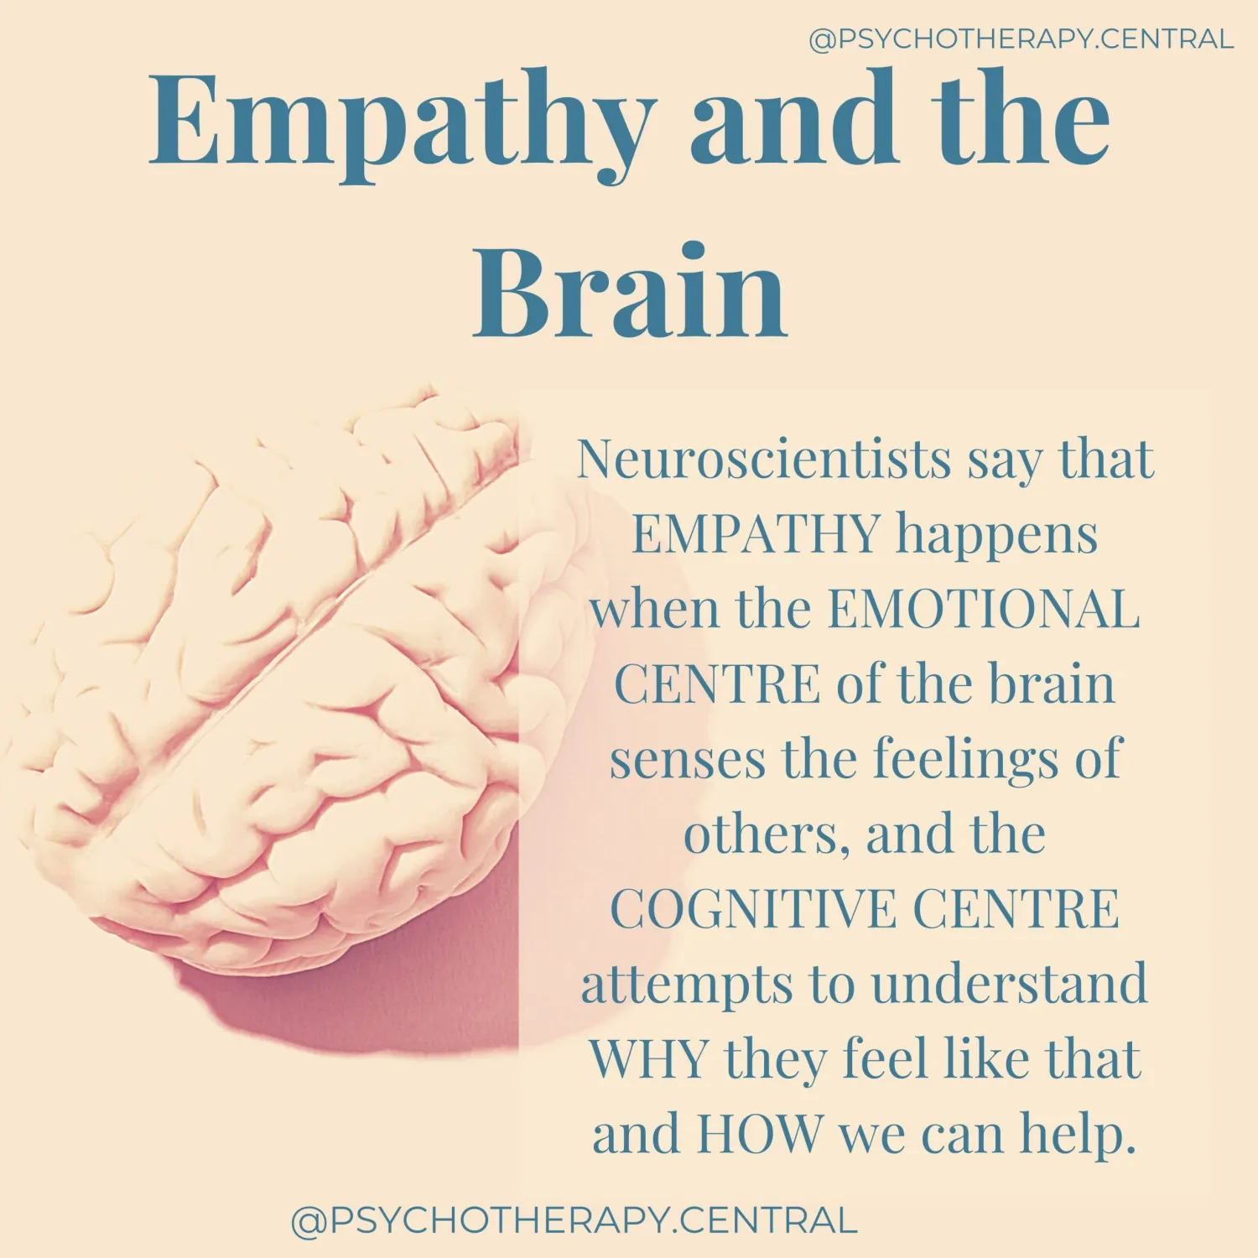
https://www.nature.com/articles/s41386-022-01286-5
- Article
- Published: 08 February 2022
Associations between social behaviors and experiences with neural correlates of implicit emotion regulation in middle childhood
Emotion regulation is essential for successful social interactions and function, which are important aspects of middle childhood. The current study is one of the first to examine associations between neural correlates of implicit emotion regulation and indices of social behavior and experience during late middle childhood. We examined neural activation during the implicit emotion regulation condition of the Emotional N-back task using data from 8987 9- to 11-year-olds from the Adolescent Brain Cognitive Development℠ study. The brain regions assessed included areas linked to social cognition, social behavior, and emotion recognition, including the amygdala, insula, middle temporal gyrus, and inferior parietal lobe. Greater number of close friends was associated with significantly higher activation of the fusiform gyrus, insula, temporoparietal junction, inferior parietal lobe, and superior temporal gyrus during implicit emotion regulation. Greater reciprocal social impairments were linked to decreased fusiform gyrus activation during implicit emotion regulation. More experiences of discrimination were associated with a significantly lower activation in the middle temporal gyrus during implicit emotion regulation. This study provides evidence that both positive and negative indices of children’s social experiences and behaviors are associated with neural correlates of implicit emotion regulation during late middle childhood. These findings suggest that both positive and negative indices of social behavior and experience, including those within and not within the youth’s control, are associated with generally unique neural correlates during implicit emotion regulation.
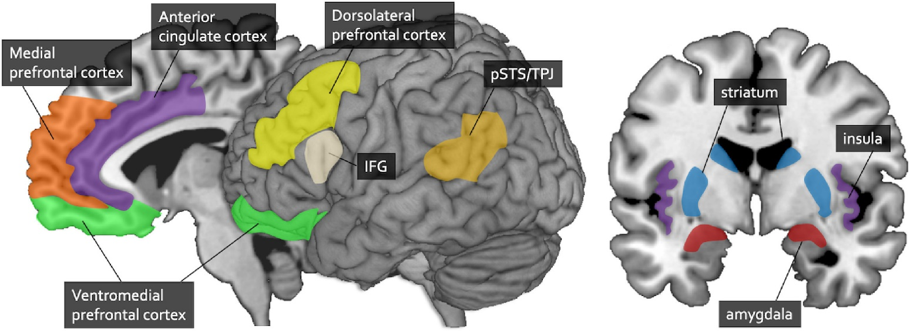
https://www.amjmed.com/article/S0002-9343(20)30022-X/abstract
It is acknowledged that empathy plays a critical role in the physician-patient relationship and has a positive impact on health outcomes. However, as the field of empathy expands, the lack of conceptual coherence challenges advances in medicine. In fact, in some medical settings, there is little added theoretical or clinical value in applying the all-encompassing term of empathy, which is by nature multidimensional, interpersonal, and modulated by context. Functional neuroimaging studies of health professionals, designed to examine patterns of brain activation in response to empathy-eliciting situations, bring theoretical clarity to the neurocognitive mechanisms that underlie interpersonal sensitivity, emotional empathy, cognitive empathy, and caring. These components are relatively independent but often interact and are deeply interwoven in the fabric of the brain. Nevertheless, it seems clear from this review that cultivating empathic concern or compassion in today's medicine is more important than other aspects of empathy, like vicariously experiencing and introspecting about patients' emotions. Specific neurobiological mechanisms explain the benefit to patients of their physicians’ perceived empathy.
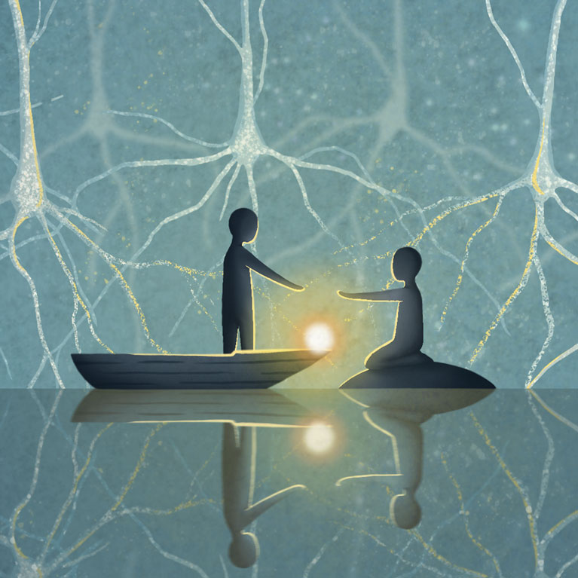
Now that we have firmly established the variety of neuroscience relevant ways empathy is measured in the brain with fmri and how those measurements are used to develop databases for the internet of behaviors, I hope as a rational person you can “empathize” with those of us who were raised in a society that told us very sternly empathy does NOT exist. It’s woo-woo and we were over sensitive or just needed more medications; rather than human to human connection and the opportunity to hone our skills with our biofield and body to protect ourselves and greet the world with more confidence in our somatoform.
This is where the fundamental disconnect is for many people who have lived life with their empathic abilities in tact in spite of societal bullying. Now that the internet of behaviors is a corporate landscape of purchasing body data and ordering neuromodulation; empaths who are not using bioelectronic wearables or taking multiple chemical compounds (drugs, prescription or street) are bioelectrically fending off multiple neurological signals and impulses that magnetically pull their cells in another direction than their own endocrine system.
It’s important to note that our ability to function through these transhumanism upgrades to other bodies is also made difficult by natural cellular or molecular communication with those bodies.

Psinergy Definitions of Empathic Abilities
Projective Empathy
When you send your emotions towards another person to convince them of something or overpower their emotional state with your own.
This can be used for positive effects in leadership situations, teamwork environments to expedite projects or in fast decision paced moments. However, often the people that purposely project their emotions onto others is a format of manipulation or control; a desire to dominate the other person’s responses. Some people used to call these kinds of practices “psychic vampirism” and other such nomenclature because of the left over feeling once the projective empath is gone of being drained of your energy.
While projective empaths can wield their abilities for positive outcomes, most often a practice of temperance must be integrated because empathy is a function of your endocrine system and is very powerful in all layers of the extended biofield (biofield elongation). The longer you extend your field over top of the other person(s) the more biofield concurrence you maintain and that is the real energy drain.

Receptive Empathy
The function of absorbing another’s emotions and either disassociating the emotions from a situation or mirroring the incoming empathic signals.
Receptive empaths as noted above in neuroscience can have a negative effect of taking on other’s emotions at rates that their own endocrine system cannot sustain. This is a literal cause and effect of ion channels in our cells as well as biofield concurrence. Receptive empaths can often help others feel states of euphoria or relief at the cost of their own cellular energy. Receptive empaths can negate emotional escalation without engaging conversation often by vibrating the signal towards everyone and creating a vortex effect of the energy exchange between the other biofields. However, this is a temporary fix because eventually the cognition of the challenge will rise again. Receptive empaths often find themselves introverted to avoid the constant energy drain and sometimes have had too many interactions with people who purposely target their ability to make others feel better naturally.
Healing Empaths
Healing empaths purposely elongate and compress their biofield in order to attenuate their biofield to another (such as a client) for biofield concurrence.
Healing empaths harness their natural endocrine and fascia systems as they work with their biofield to hold proper ionic channel allocation for molecular or cellular communication. As noted in the neuroscience it is observed that there may be some format of ‘entanglement’ going on. Healing empaths often have their own practices to clear their biofield and repair themselves before moving to the next client; but sometimes it takes more time than preferred. Healing empaths are often more versatile and able to help the fluctuation of natural energy in any environment even out as the accordion effect of their own personal biofield use extends to the dynamic energies of humans connecting in real time. Healing empaths usually are often able to oscillate neuronally between receptive and projective empathy to the best advantage of biofield concurrence as it is a practice with their applied healing modality.
https://pmc.ncbi.nlm.nih.gov/articles/PMC8296239/#sec5-ijerph-18-06397
Int J Environ Res Public Health
. 2021 Jun 13;18(12):6397. doi: 10.3390/ijerph18126397
Perspectives, Measurability and Effects of Non-Contact Biofield-Based Practices: A Narrative Review of Quantitative Research
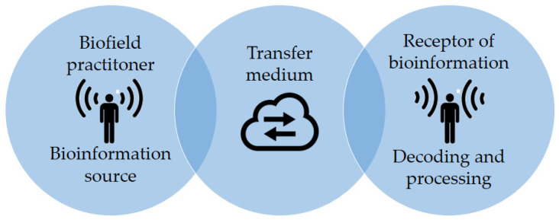

According to several authors, this phenomenon could be partially related to electromagnetics [20,21,22,23,24,25,26,27,28,29,30], to acoustic- and thermal-related effects [31,32,33,34], and possibly subtle energy fields, which, in some cases, seem to generate physical changes that are measurable with current technological methods, and related to health or disease patterns [13,35,36]. On the other hand, some practices appear to act in a manner described as nonlocal and unmediated, defying conventional scientific concepts [24,37], possibly compromising consciousness and transpersonal realms of being often associated with spirituality [17].
Robert O. Becker, an orthopedic surgeon who developed research on electrophysiology, authored “The Body Electric. Electromagnetism and the Foundation of Life”. In this work, Becker claims that the current flows over the nerves’ perineural structures, traveling from the brain, that presents a higher electropositive potential to the body’s periphery. He also found a direct relationship between current, tissue growth, and healing processes by measuring the DC electrical potential and current involved in spontaneous and induced regeneration in various species such as salamanders, frogs, and rats. A remarkable level of limb regeneration in adult frogs was reported by applying a negative polarity current to the post-amputation stump, and that fractures of the long bones in frogs demonstrated a negative polarity along with apparent dedifferentiation of the erythrocytes in the fracture hematoma, which later formed the bone “callus” responsible for healing the fracture [45]. His results show that bone can generate potentials by the piezoelectric effect and that the natural repair of bone fractures can be stimulated by electric current [13,20].
Björn Nordenström was Chairman Emeritus of the Department of Radiology at the Karolinska Institute. He also chaired the Nobel Assembly Committee that selects the Nobel Laureate in Physiology and Medicine and has performed remarkable research on cancer treatment. He developed the electrical circulatory system theory, where the body is composed of “biologically closed electrical circuits”. In this model, the body’s electrical communication system can be compared to a battery in which the separation of oppositely charged ions drives the circuit. He noticed that when the tissue is damaged by injury or malignant growth, there is a build-up of positively charged ions in the affected area, whereas the adjacent healthy tissue is negatively charged. In his book entitled “Exploring BCEC-Systems (Biologically Closed Electric Circuits)”, he points out that ancient Oriental philosophy and approaches are related to his theory, considering that “qi” is analogous to the energy flow through his electrical circulatory system and that yin and yang deal with negative and positive charges, respectively [29,46].
The healing process established between a healer and a patient might involve entanglement and some form of mutual awareness.
Studies involving neuron-to-neuron, brain-to-brain, and person-to-person connections have been carried out. The work of Pizzi et al. [66] showed that by stimulating a group of human neurons with a laser beam, a different group of neurons placed at a distance exhibited similar changes, although the two groups were entirely shielded from each other [66]. Other studies point towards changes in the alpha rhythms of twin’s brains when one of the subjects, away from his brother, closes his eyes. Changes in patients’ brains, detected by functional magnetic resonance imaging (fMRI), are also detected when healers focus their distant intention to heal [59].
Some experiments suggest that water’s physical properties, such as the cooling rate, molecular bonding reflected by infrared spectra alterations, Raman spectroscopy, scattered laser light, and the pH level, may be influenced by intention
Measuring the Effects of Biofield Practices
The biofield hypothesis and related healing practices require the existence of a measurable “healing energy” that, whether produced by a device or projected from the human body, has a particular frequency or set of frequencies that stimulates the repair of one or more tissues. The cascade of activities initiated by such signals may provide essential information to cells and tissues and open channels for information flow that coordinates both prevention and repair processes [35,85].
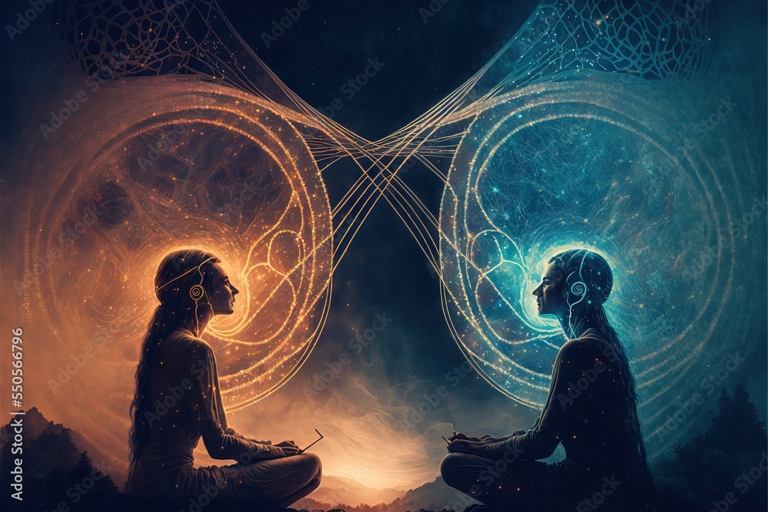
Empathy is neuroscience.
When you choose to engage your natural quantum brain, fascia, biofield and endocrine system; you are actuating a physiological signal change with your own bioelectricity and neuronal networks. The more you work with shielding your body, dismissing cellular signaling you do not want to be in phase with and insulating your heart with self care, the easier it is to move through the world keeping your energy more balanced.
The following sections are excerpts from previous classes I taught or articles I wrote.
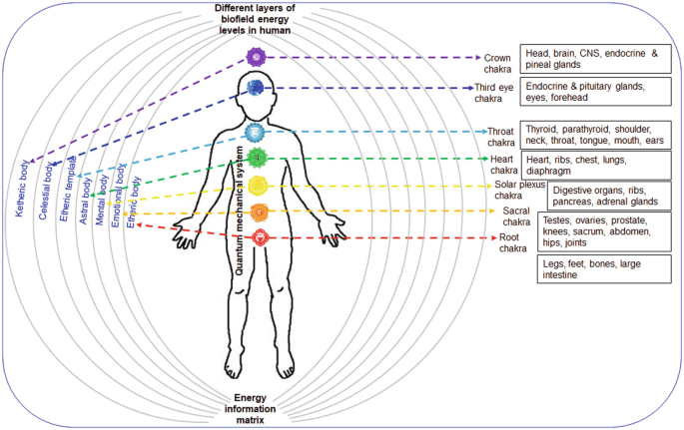
From 2004:

Empathy
Empathy is a well-known and often subconscious sense that all human beings share and develop over time. Some people are more receptive than projective. For example, a receptive empathy is the person who has a hard time dealing with the overtly negative people in his/her home or job. These people may seem aloof most often because the smallest emotional exchange can seem overwhelming at times in their perception. A projective empathy may be the person whose moods inadvertently affect everyone around them on a routine basis. They may be more dramatic and very excitable people as they ‘flare’ their emotions when communicating, particular when speaking.
Emotions are a form of energy within the body. If you have ever cried yourself into exhaustion when having lost a loved one, you can surely understand the power of emotions on the body as well as the mind. It is imperative that Empaths (people who use their empathy) take the time to balance and protect themselves from the typical outpouring of emotions in both the workplace and the home.

Recognize that there is a difference between being over-sensitive to a situation and being empathically ‘saturated’ with negativity. When you are over-sensitive to a situation, generally you realize that the situation has affected you personally and you need to address the reasoning within yourself. When you are being empathically saturated, the person with whom you are dealing with may be angry at you or the situation he/she is in and when they leave you, you will feel tired, angry for no reason, depressed, moody or otherwise ‘not yourself’. One of the most typical responses from a saturated empath is that they feel ‘covered in slime’ or ‘coiled like a spring’. An emapth will also experience powerful emotions that are not necessarily coming from within themselves. After helping a close friend with an emotional problem in her/her relationship, you may feel lingering anger/discord with your friend’s partner that reaches far beyond your personal judgment or rational thoughts. This type of ‘saturation’ is one of the ways we support one another as human beings. Compassion, in its purest form, is empathy. We take on other’s pain and comfort them, giving them the support and understanding necessary to uplift them. In this transaction, since energy is neither created nor destroyed, energy is exchanged and empaths often find themselves quite ‘heavy’ with emotions and unsure of how to ‘purge’ themselves or ‘clear’.
There are several ways to approach clearing and balancing your body and mind. Religious traditions and rites over time have utilized many methods. Every person tunes into themselves and the world differently, so it may take some time for you to find your specific method.
One method is by balancing yourself utilizing meditation; deep breathing and a calming atmosphere, preferably with a soothing aroma and soft music, is a great way to begin. You can also use stones or crystals to help focus on the parts of your body that need to be ‘rebalanced’. Remember that your body, like your skin, is composed of many layers. These layers can be accepted as a visual aid or as something you can reach, depending on your beliefs. Allow yourself to explore these layers and energy points on the body at your own pace and distinguish them as you see fit for you alone.
No one can tell you what you feel in your own body.

Over time you may find that you need to switch stones to different locations on your body or visualize a different technique. Feel free to improvise and shift your patterns as necessary. Ultimately you are your own guide.
This meditation was designed specifically for an empathic person who needs help re-balancing and clearing their body of unwanted negativity or emotional clutter.
~
Find a comfortable setting wherein you will not be disturbed for preferably 30 minutes.

Using a pendulum, find the primary 7 energy centers (from here out referred to as chakras) on your body.
**You do not need to dowse (using the pendulum is called dowsing) every time you begin your meditation. Eventually you will become familiar with your chakras and be able to simply begin your meditation. If in the future you feel one chakra may need more balancing than another, you may dowse to determine that.**

Take 3 deep breaths, in through the nose, out through the mouth. Relax your shoulders and roll your neck a few times to allow the kinks to settle. Stretch your hands and bend your toes. Become aware of your body, from your toes to the top of your head.
Sit down on the floor and prepare to lie down by ensuring you have a pillow handy. Make sure the room is a comfortable temperature and if necessary, place a pillow below your knees.
Begin by placing the stones on your primary chakra points beginning with the root chakra, typically between the ankles. The last stone of the 7 you should place directly above your head, touching the top of your scalp.
Begin Vasculature Aware or “Chakra” (nodal point) Meditation:
This meditation can be done very quickly or you can spend some time focusing on each color. You will want to have pencil and paper handy to use following your meditation to write down any impressions you received. This meditation can strengthen each chakra center by visualizing its vibratory color. You may notice that some centers are easier to visualize and fill with color than others. Some centers may need an endless amount of color and you may not be able to visualize some. Any impressions should be noted after the meditation.
After you have grounded and centered yourself and are in a relaxed comfortable position, close your eyes and picture a large brilliant white light suspended above your head. All of the colors you draw down should come from this brilliant white light sphere above your head.
First picture a strong red light in the sphere. Draw it down into your body, down the spine and into the root chakra. Let the color completely fill the chakra and allow any overflow to pass into the earth.
Next pull the color orange out of the sphere and bring it down the spine into the lower abdomen. Fill the area of the sacral chakra with the color orange and allow any overflow to pass into the earth.
Move back up to the white light and let the color yellow enter the body, move down the spine and fill the solar plexus area. Again fill the area with this bright yellow light, leaving no area in shadow and allow any excess to flow down into the earth.
Now move the vibrant rich green light from the sphere above your head and fill the heart chakra. The heart chakra is your center and you will experience a balancing, calming effect when this chakra is filled. Allow any excess to flow into the earth.
Next move the sky blue color from the sphere and fill the throat center with this cool blue light. Move the excess into the earth.
Take the deep midnight blue color and move it into the third eye. Feel the quite calm as this indigo color fills the brow chakra. Let any extra indigo light flow into the universe.
Finally draw down a soft violet light and pour it over your crown chakra. Allow this violet color to pour over your entire aura in a continuous steady stream; it will protect and balance all aspects of the self.
Slowly count to 10 and open your eyes. Jot down any impressions.

# | Symbolic location | Divinatory meaning | color
7th | Crown chakra: top of the head | Cosmic consciousness, brain, nervous system | violet
6th | Brow (third eye) chakra: middle of the forehead | Inner and outer vision | indigo
5th | Throat chakra: base of the throat | Communication and self-expression, arms and hands | sky blue
4th | Heart chakra: center of the chest | Balance, love, circulatory and immune systems | green
3rd | Navel chakra: navel :) | sense of power, energy. skin, intestines. | yellow
2nd | Spleen chakra: center of the abdomen below the navel | how energy is converted and processed, sexuality, emotions, creativity | orange
1st | Root chakra: perineum (area between anus and genitalia) | survival, grounding, habits, elimination system, adrenal glands, lower extremities | red

When you can connect to yourself and process your own blood flow and nodal points of internal organ connectivity you can begin to work with others. Here is an example of a beginner class.

Beginners Class Outline

Class 1

- Breathe & Center & Focus & Relax
  - Personal connect
  - Group connect
- State Intent/Journey
  - What do you want to learn from this class?
  - Where do you see yourself going in the next year with your gift-sense?
  - How will learning your gift-sense more empower/help you?
- Identify Gifts
  - What do you think your gifts are?
    - Connect to Telepath
    - Connect to Empath
    - Connect to Tele-Empath
  - Which connection best suited you?
    - High frequency transmission
    - Low frequency transmission
  - Primary Gift
  - Secondary Gift
  - Attainable Gift
- Self-Healing
  - Intro to TT
    - Self Healing
  - Intro to HT
    - Direct to websites and information
    - Disclaimer on HT at this time
  - Intro to Chakra Balancing on self
    - Optional chakra stones
    - Demonstration on volunteer
  - Chakra balancing self energy exercise
- Review & Discussion
  - Pass the energy ball and group connect/release

Class 2
- Clearing Space
  - Why do we clear space?
    - To feel more clear
    - To feel more safe
    - To make a more psychic conducive environment
  - Deciding where to clear space
    - In room only
    - In house
    - On block
  - Deciding How to clear space
    - Shamanistic with sage & chanting
    - Your own energy
    - Cutting – Clearing – Sealing technique
      - Tools
        - Cutting the Space
        - Clearing the space
        - Sealing the space
- Detecting nodes & Lei lines
  - Carefully!
- Setting up space to be most conducive to your energy work & your personal environment
  - Different rooms
  - Using portals and gates
  - Usting clearing spaces
- Shielding Space
  - Bubble shield around the house that can fluxuate and keep you safe
- Pass the colored energy ball
- Review & Discussion

Class 3
- People Connections
  - Awareness of different talents
  - Setting up a good circle
    - Transfusers in the middle
    - T – E – TE approach
    - BALANCE!
  - Sensing personal boundaries
  - Combining energies for group shielding
    - All of your energy or intent together
    - Bubble shield as a whole
- Energy through circles and other shapes
- Sacred Geometry with people and objects
- Practice
  - Clear space
  - Set Space
  - Select People
  - Select shape based on number of people/what works best
  - Center & Focus & Connect, make changes
  - Combine energies and shield
- Review & Discuss
- Discuss final class

Class 4
- 4 hour class
- 20 min intro and lite dinner
- Potluck afterwards

- Split into 2 groups
- 1 hour to prepare to CFE –
  - shield the group
  - support the energy
  - run it smoothly
  - Connect up and down – Raise and lower energies
  - Connect charkas in relaxed setting – raise energy ball and release
  - Clear and take down space
- Review & Qs
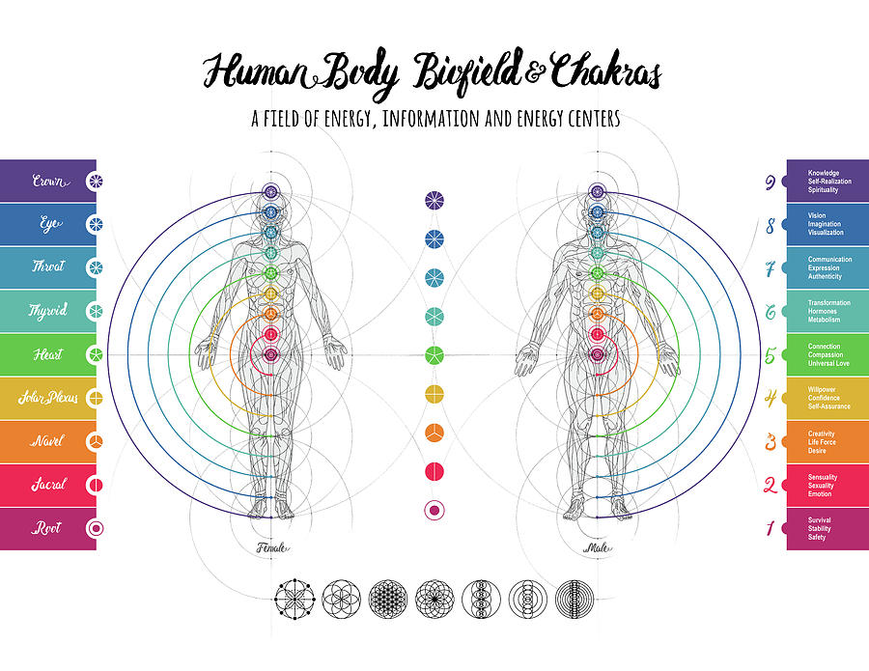
Finally, connecting biofield to biofield creates links to other bodies just like links to websites on the internet.
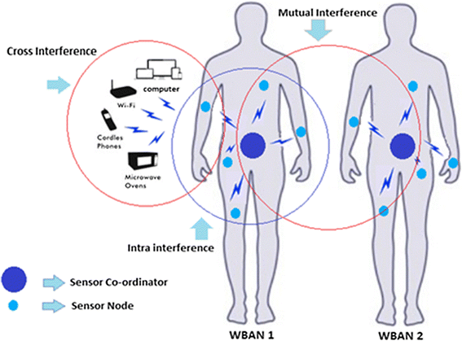
From 2002:
Linking Structures
A link is a connection via energy from one person to another.

Physical touch = short range
Astral touch = long range

Both physical & astral touch can be switched out as long range or short range. Most telepaths & transfusers prefer not to use physical touch in order to transfer during ritual.
Links are built first as constructs in one of 3 modes; Simplex, half-duplex or duplex.
Links are lines of energy, what you infuse into the core of that line, similar to cabling, is what makes the link work.
(YOUR BODY IS THE TRANSMISSION MEDIUM – HUMAN BODY COMMUNICATION)
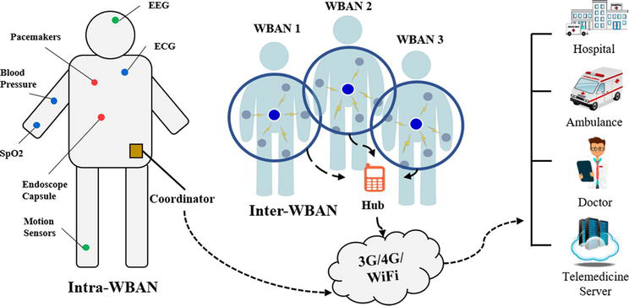
What to take into account when assembling the initial construct to build a link:
- High or Low frequency receptor
- How much bandwidth is necessary
- How often do both ends need to be open
- How fast does the link need to travel on a regular basis
- Shileding & encoding properties
- Connection overlays
- Soul
- Human
- Messenger only
- High freq only
- Low freq only
- Color- raw freq
- Designated drop cycle overlays
- What will power the link
- Intent
- Pure form intrinsic
- Personal
- Both
- External sources
- Network resources
- Energy type
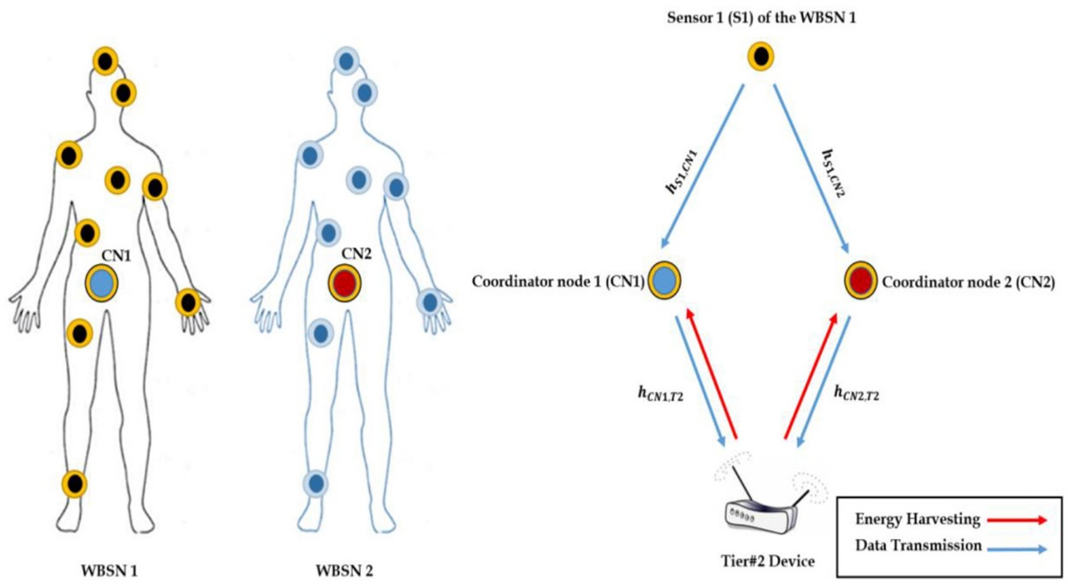
You must first choose what color you want the link to be in or insert the correct frequency as you weave the structure itself. Programming in the types of overlay and powering processes will come later.
Once you have the color you must choose the mode, one way, two way or both ways simultaneously. Once that choice is made you must evaluate your receptor and your own ability to operate with the link to determine level placement i.e. is it on all the time or just in the mornings or during ritual?
Once that is chosen you may begin inserting programs indicating what power sources the link should draw from for normal and back up procedures.
You choose your overlays and encoding. What does this link need to do? Does it do this on its own or with subconscious instruction? Do you have conscious instruction codes to input in the event of A, B, or C situations?
Finally part two is lacing the energy types you want running down this linking structure. (healing/reductive/capacitive/galvanic)
~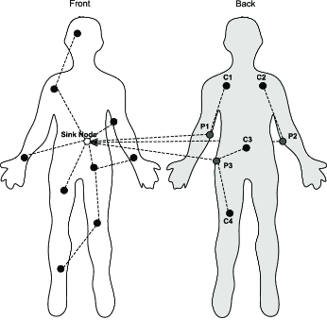
Questions to Consider for your Journey
How do I feel when I am in certain environments? Do these spaces empower me or create endocrine system disruption?
Am I ‘trapped’ in those environment by obligation or am I allowing the instances to take place regardless of the physiological effect?
Is it easier to block out all signals or interact with those emotional signals in a way that is to my own benefit even if it is to another’s detriment?
Is healing others a large component of what could be my soul’s purpose and if so, how do I find a healing modality that meets my neuronal network oscillation given there are so many modalities to learn?
What kinds of physiological effects does sound have on water (and thus bodies) and does any of it alter your personal body when seeking relief?
~
Suggestions
Take this pdf to a coffee shop with like minded empaths and bring highlighters. Discuss the neuroscience sections that are pertinent to your current learning curves. Ask one another about variant experiences with the same types of connectivity.
Create a class that meets once a week in a safe environment that is quiet and healing oriented. Exchange energy and practice sending emotions, just one at a time to one another in sets of two. After about 15 minutes go to the next partner and reset your field as you do so. Learning to connect and disconnect biofield concurrence can help you manage your oscillation of your endocrine system more effectively.
Open an X space or other platform and discuss how empathy has facilitated you in your life and ask others to share their experiences inclusive to physiological responses to other bodies and situations. Exchange mechanisms or processes that assisted you in maintaining your bioelectrical homeostasis.
Thank you for taking the time to be a human with all your body parts. Whatever you do from here, knowing these abilities are just part of the natural human body will be a benefit to any other humans you are able to teach. The more we “innerstand” how our body works in tandem with our literal bioelectrical neuronal density (consciousness) the better off we are as a species. Self work is internal; how we wield our empathy is eternal.
May you be blessed upon your journey of rediscovering how amazing you already knew you are
